**My Design Document**

**Jacob Williams**

**INTERFACE DESCRIPTION**

The interface shows a dart flying through the air towards a dart board. The dart also has a small “star” moving around it. Also visible in the scene are: a table, a drinks bar, a drinks shelf behind the bar, ceiling lights and ceiling/floor/walls. The user is also able to control when the dart is initially thrown and can control the dart during its flight.

**IMAGE REFERENCES**

* bar_side.jpg
  + <https://www.crystalgraphicsimages.com/photo/old-wood-texture_cg1p5065645c_th.jpg>
* bottles.jpg
  + <http://bgfons.com/uploads/rainbow/rainbow_texture659.jpg>
* brick_wall.jpg
  + <https://www.poliigon.com/texture/bricks-01#top_slider>
* ceiling.jpg
  + <https://www.poliigon.com/texture/plaster-17#top_slider>
* light_panel.png
  + <https://t6.rbxcdn.com/997bd795abeceee47363c78200a553df>
* table_top.jpg
  + <https://www.poliigon.com/texture/wood-planks-worn-33#top_slider>
* target.png
  + <http://png.clipart-library.com/images4/1/archery-vector-board-4.png>
* wood_floor.jpg
  + <https://www.poliigon.com/texture/wood-flooring-044#top_slider>

**OBJECTS**

Plane – This is used for a wall / floor / ceiling

x

z

v3

v4

v2

v1

|  |  |  |  |
| --- | --- | --- | --- |
| **Vertex** | **x** | **y** | **z** |
| v1 | -0.5 | 0 | -0.5 |
| v2 | 0.5 | 0 | 0.5 |
| v3 | 0.5 | 0 | 0.5 |
| v4 | -0.5 | 0 | 0.5 |

Coordinates Faces

|  |  |
| --- | --- |
| **Face** | **Vertices** |
| Near Face | v4, v3, v2, v1 |

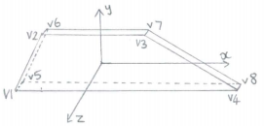Dart Fin – This is used for a fin of the dart

|  |  |  |  |
| --- | --- | --- | --- |
| **Vertex** | **x** | **y** | **z** |
| v1 | 0.01 | 0 | 0.33 |
| v2 | 0.01 | 0.15 | 0.3 |
| v3 | 0.01 | 0.15 | -0.3 |
| v4 | 0.01 | 0 | -0.66 |
| v5 | -0.01 | 0 | 0.33 |
| v6 | -0.01 | 0.15 | 0.3 |
| v7 | -0.01 | 0.15 | -0.3 |
| v8 | -0.01 | 0 | -0.66 |

Coordinates Faces

|  |  |
| --- | --- |
| **Face** | **Vertices** |
| Near face | v6, v5, v1, v2 |
| Left face | v7, v8, v5, v6 |
| Right face | v2, v1, v4, v3 |
| Top face | v6, v2, v3, v7 |
| Bottom face | v3, v4, v1, v5 |
| Back face | v3, v4, v8, v7 |

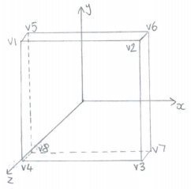Dart Board – This is used for the dart board

|  |  |  |  |
| --- | --- | --- | --- |
| **Vertex** | **x** | **y** | **z** |
| v1 | -2.5 | 2.5 | 0.1 |
| v2 | 2.5 | 2.5 | 0.1 |
| v3 | 2.5 | -2.5 | 0.1 |
| v4 | -2.5 | -2.5 | 0.1 |
| v5 | -2.5 | 2.5 | -0.1 |
| v6 | 2.5 | 2.5 | -0.1 |
| v7 | 2.5 | -2.5 | -0.1 |
| v8 | -2.5 | -2.5 | -0.1 |

Coordinates Faces

|  |  |
| --- | --- |
| **Face** | **Vertices** |
| Near face | v4, v3, v2, v1 |
| Left face | v1, v5, v8, v4 |
| Right face | v2, v3, v7, v6 |
| Top face | v1, v2, v6, v5 |
| Bottom face | v3, v4, v7, v8 |
| Back face | v8, v7, v6, v5 |

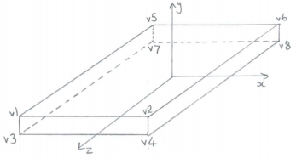Table Top – This is used for the top of the table

Coordinates Faces

|  |  |  |  |
| --- | --- | --- | --- |
| **Vertex** | **x** | **y** | **z** |
| v1 | -2 | 0.2 | 4 |
| v2 | 2 | 0.2 | 4 |
| v3 | -2 | -0.2 | 4 |
| v4 | 2 | -0.2 | 4 |
| v5 | -2 | 0.2 | -4 |
| v6 | 2 | 0.2 | -4 |
| v7 | -2 | -0.2 | -4 |
| v8 | 2 | -0.2 | -4 |

|  |  |
| --- | --- |
| **Face** | **Vertices** |
| Near face | v3, v4, v2, v1 |
| Left face | v1, v5, v7, v3 |
| Right face | v2, v4, v8, v6 |
| Top face | v1, v2, v6, v5 |
| Bottom face | v4, v3, v7, v8 |
| Back face | v8, v7, v5, v6 |

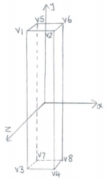Table Leg – This is used for a leg of the table

Coordinates Faces

|  |  |  |  |
| --- | --- | --- | --- |
| **Vertex** | **x** | **y** | **z** |
| v1 | -0.1 | 1 | 0.1 |
| v2 | 0.1 | 1 | 0.1 |
| v3 | -0.1 | -1 | 0.1 |
| v4 | 0.1 | -1 | 0.1 |
| v5 | -0.1 | 1 | -0.1 |
| v6 | 0.1 | 1 | -0.1 |
| v7 | -0.1 | -1 | -0.1 |
| v8 | 0.1 | -1 | -0.1 |

|  |  |
| --- | --- |
| **Face** | **Vertices** |
| Near face | v3, v4, v2, v1 |
| Left face | v1, v5, v7, v3 |
| Right face | v2, v4, v8, v6 |
| Top face | v1, v2, v6, v5 |
| Bottom face | v4, v3, v7, v8 |
| Back face | v8, v7, v5, v6 |

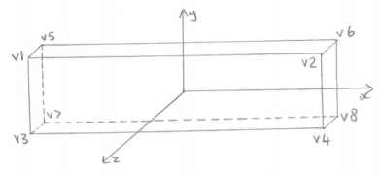Bar – This is used for the drinks bar

Coordinates Faces

|  |  |  |  |
| --- | --- | --- | --- |
| **Vertex** | **x** | **y** | **z** |
| v1 | -25 | 1.5 | 1 |
| v2 | 25 | 1.5 | 1 |
| v3 | -25 | -1.5 | 1 |
| v4 | 25 | -1.5 | 1 |
| v5 | -25 | 1.5 | -1 |
| v6 | 25 | 1.5 | -1 |
| v7 | -25 | -1.5 | -1 |
| v8 | 25 | -1.5 | -1 |

|  |  |
| --- | --- |
| **Face** | **Vertices** |
| Near face | v3, v4, v2, v1 |
| Left face | v1, v5, v7, v3 |
| Right face | v2, v4, v8, v6 |
| Top face | v1, v2, v6, v5 |
| Bottom face | v4, v3, v7, v8 |
| Back face | v8, v7, v5, v6 |

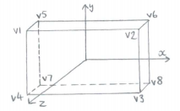Shelf – This is used for the shelf behind the drinks bar

Coordinates Faces

|  |  |  |  |
| --- | --- | --- | --- |
| **Vertex** | **x** | **y** | **z** |
| v1 | -10 | 1.5 | 1 |
| v2 | 10 | 1.5 | 1 |
| v3 | -10 | -1.5 | 1 |
| v4 | 10 | -1.5 | 1 |
| v5 | -10 | 1.5 | -1 |
| v6 | 10 | 1.5 | -1 |
| v7 | -10 | -1.5 | -1 |
| v8 | 10 | -1.5 | -1 |

|  |  |
| --- | --- |
| **Face** | **Vertices** |
| Near face | v3, v4, v2, v1 |
| Left face | v1, v5, v7, v3 |
| Right face | v2, v4, v8, v6 |
| Top face | v1, v2, v6, v5 |
| Bottom face | v4, v3, v7, v8 |
| Back face | v8, v7, v5, v6 |

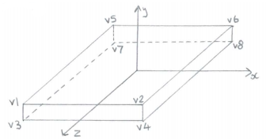Light – This is used for a ceiling light

Coordinates Faces

|  |  |  |  |
| --- | --- | --- | --- |
| **Vertex** | **x** | **y** | **z** |
| v1 | -0.5 | 0.1 | 0.5 |
| v2 | 0.5 | 0.1 | 0.5 |
| v3 | -0.5 | -0.1 | 0.5 |
| v4 | 0.5 | -0.1 | 0.5 |
| v5 | -0.5 | 0.1 | -0.5 |
| v6 | 0.5 | 0.1 | -0.5 |
| v7 | -0.5 | -0.1 | -0.5 |
| v8 | 0.5 | -0.1 | -0.5 |

|  |  |
| --- | --- |
| **Face** | **Vertices** |
| Near face | v3, v4, v2, v1 |
| Left face | v1, v5, v7, v3 |
| Right face | v2, v4, v8, v6 |
| Top face | v1, v2, v6, v5 |
| Bottom face | v4, v3, v7, v8 |
| Back face | v8, v7, v5, v6 |

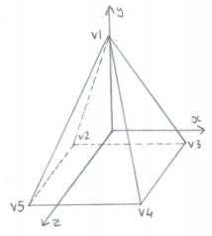Star – This is used for the star around the dart

Coordinates Faces

|  |  |  |  |
| --- | --- | --- | --- |
| **Vertex** | **x** | **y** | **z** |
| v1 | -0.5 | 0.1 | 0.5 |
| v2 | 0.5 | 0.1 | 0.5 |
| v3 | -0.5 | -0.1 | 0.5 |
| v4 | 0.5 | -0.1 | 0.5 |
| v5 | -0.5 | 0.1 | -0.5 |

|  |  |
| --- | --- |
| **Face** | **Vertices** |
| Near face | v1, v5, v4 |
| Left face | v1, v2, v3 |
| Right face | v1, v4, v3 |
| Bottom face | v2, v3, v4, v5 |
| Back face | v1, v3, v2 |